* **Literature Review:**

The use of finite element method (FEM) has been a significant tool in analyzing electric field distribution, voltage distribution, and other parameters in high voltage equipment. In this literature review, we will discuss the current state of knowledge on the use of FEM in analyzing electric field and voltage distribution in high voltage equipment.

FEM is a numerical method used to solve partial differential equations that describe physical phenomena. It has been used extensively in electrical engineering to solve problems related to electric field and voltage distribution. The method involves breaking down a complex system into smaller, simpler parts, known as finite elements. These elements are then analyzed individually, and the results are combined to obtain an overall solution for the system.

Several studies have been conducted on the use of FEM in analyzing electric field and voltage distribution in high voltage equipment, such as bushings and transformers. These studies have shown that FEM is an effective tool for analyzing these parameters and can provide accurate results for a wide range of operating conditions. FEM can also be used to evaluate the effects of different design parameters on electric field and voltage distribution, such as the shape and material properties of insulating materials.

One of the main advantages of FEM is its ability to analyze complex geometries and boundary conditions. This makes it particularly useful for analyzing high voltage equipment, which often has complex geometries and boundary conditions. FEM can also be used to simulate the effects of different types of loads on electric field and voltage distribution, such as transient over voltages and switching surges.

Several research studies have focused on developing more accurate and efficient FEM methods for analyzing electric field and voltage distribution in high voltage equipment. These studies have led to the development of advanced FEM techniques, such as adaptive mesh refinement, which can significantly reduce computational time and increase the accuracy of results. Other studies have focused on developing parallel computing algorithms to speed up FEM simulations, allowing for faster analysis of large-scale systems.

Despite its many advantages, there are still some limitations to the use of FEM in analyzing electric field and voltage distribution in high voltage equipment. One of the main limitations is the need for accurate material properties and boundary conditions. Inaccurate material properties and boundary conditions can significantly affect the accuracy of FEM results. Another limitation is the computational time required for FEM simulations, which can be quite long for large-scale systems.

In conclusion, FEM is a valuable tool for analyzing electric field and voltage distribution in high voltage equipment. It has been extensively used and validated in previous studies, and continues to be an active area of research for the development of more accurate and efficient simulation methods. The use of FEM in analyzing high voltage equipment is expected to continue to grow as new developments in computing technology and FEM algorithms make it easier and more efficient to simulate complex systems.

* **FEMM IMPLEMENTATION:**
* **Drawing & Material Labelling**

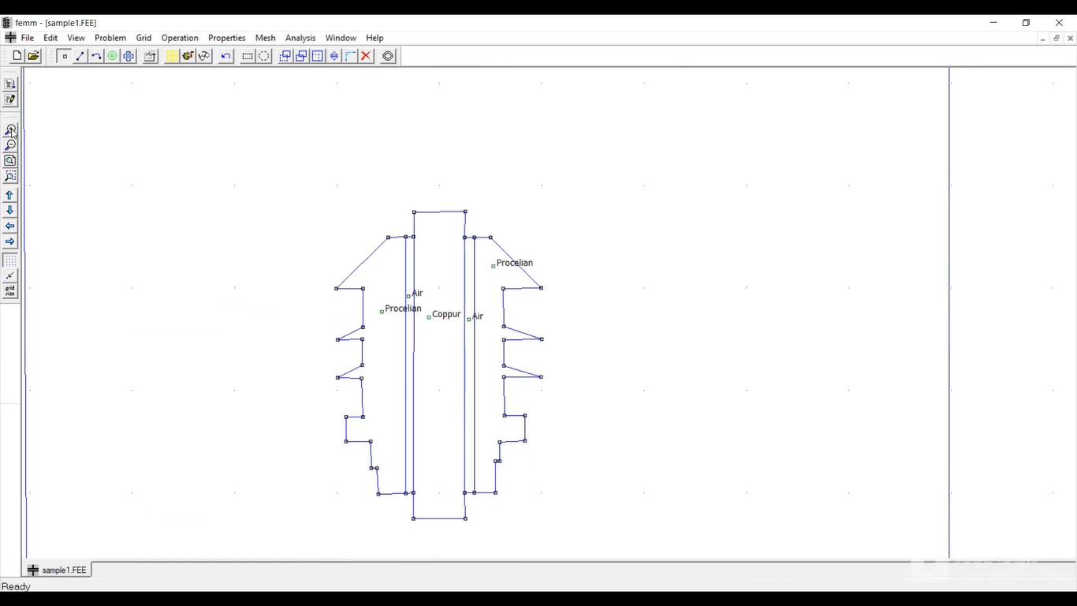

* **Created Mesh with 9463 Nodes:**

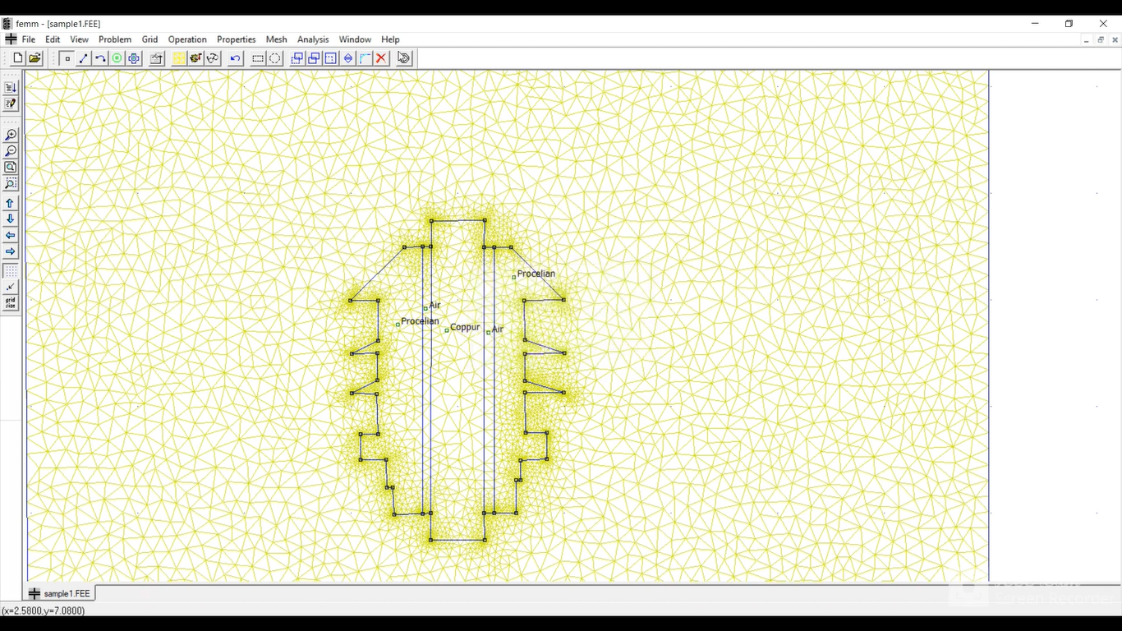

* **Results showing Electric Field Lines:**

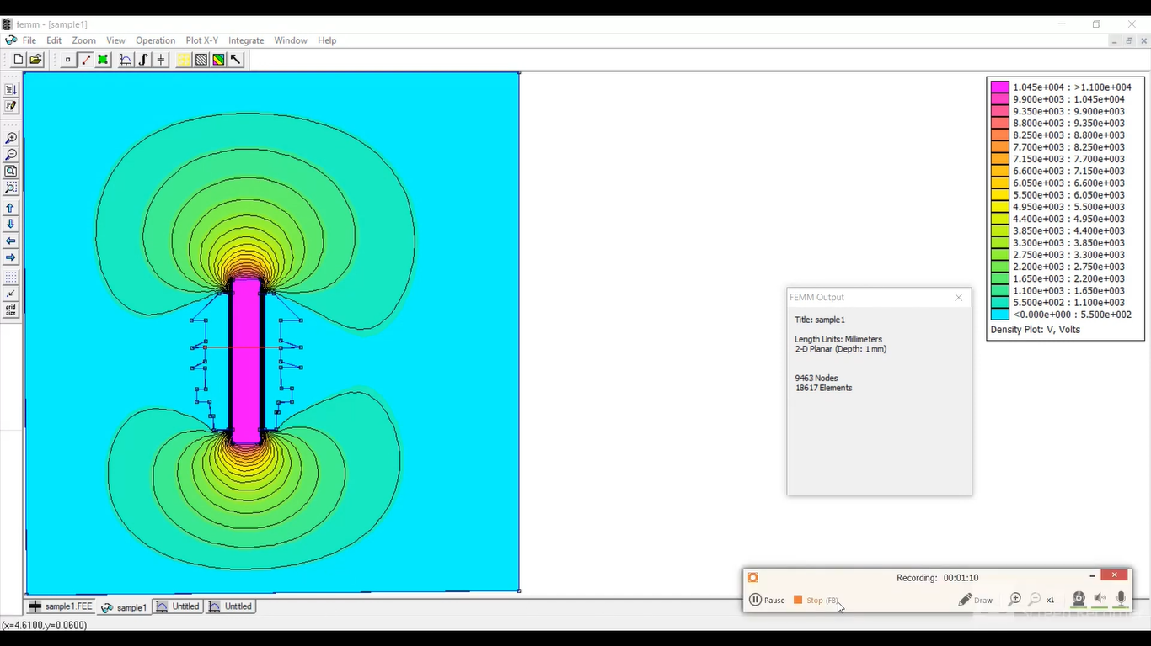

* **Voltage Graph:**

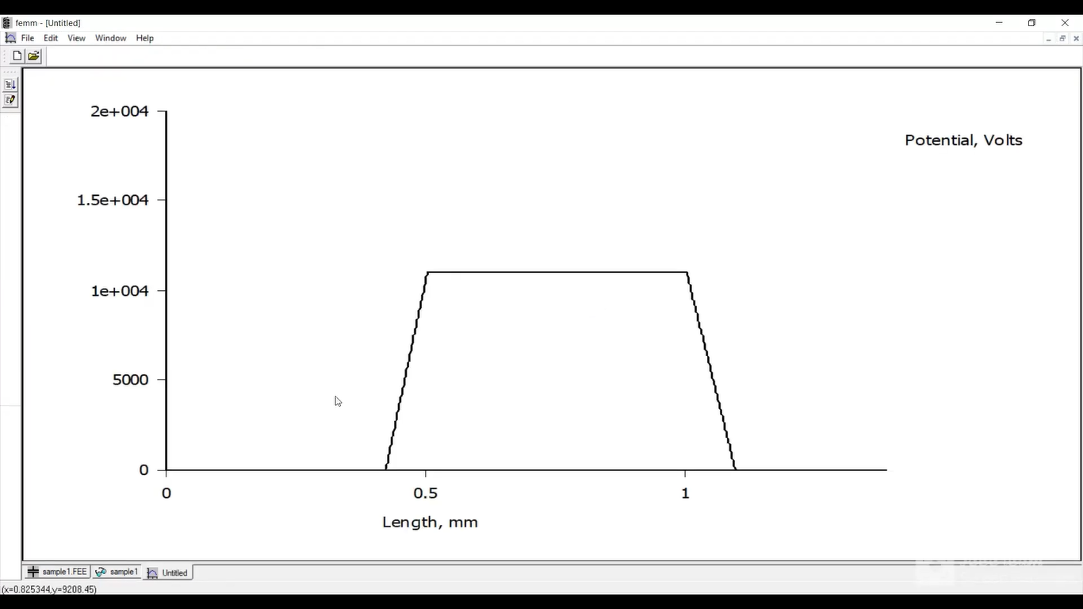

* **Magnitude & Field Intensity:**

